KHOMOTSO SWAFO
ST10523846
PROG5121 POE PART 1

1.Login class – validation methods

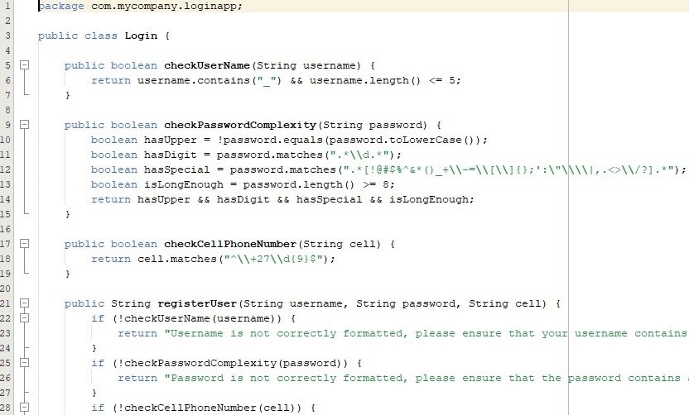

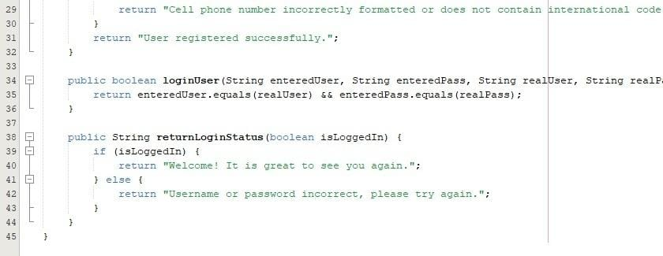
2.LoginApp class – main method
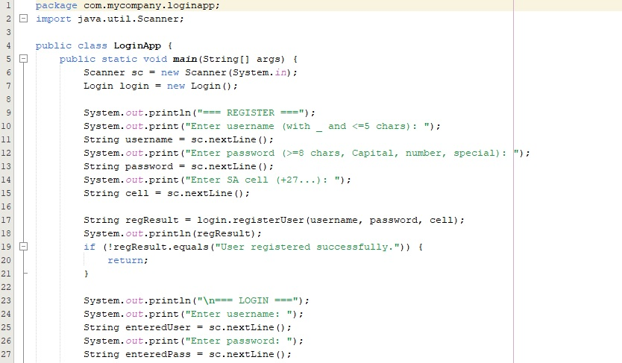

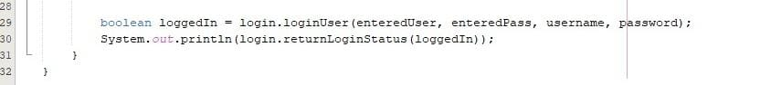
3.Output – Registration successful
